Standard Operating Procedure –

[Photo of Equipment]

Thermal Draw Tower
Written by Josh Cunningham
June 11, 2024
Version 1.0

Document Scope
This document provides an overview of the safe operating procedure for the Thermal Draw Tower used for controlling the feeder speed and winder speed (and eventually more) so that controlled experiments can be carried out to get consistently drawn fibers. The components used and the Arduino code controlling the system are essential for proper functioning but the schematic and code are not included in this document. This document only covers the hazards and safety considerations, step-wise procedure, and some notes on troubleshooting and maintenance.

Hazards and Safety Considerations
Burn Risk – furnace temperature is set at temperatures that will cause burns to skin if touched. Wear proper PPE as required when temperature is elevated
Equipment Damage Risk – drops, spills, or misuse could all result in damage to the electrical control system/Arduino.
Electrical Shock Risk – whenever electricity is in use there is a risk for electrocution or electric shocks. Inspect cords for damage before use, ensure equipment is properly grounded where possible, and never poke around at the internal electronics without powering the system down.
Hand Pinch Risk – the feed carriage slides along creating pinch points at the top and bottom where fingers could be caught and pinched, resulting in an injury somewhere between a sore finger and a smashed finger
Spinning Parts – possible to catch loose clothing, dangling jewellery, or long hair in the collection wheels of the winder

Step-wise Procedure
- Prepare a suitable preform with the material and geometry of your choice. So far, we are using a standard preform diameter of 20cm. For ease of use, we recommend a preform length of at least 200mm.
- Turn on the furnace temperature controller by flipping both the switch on the back and the switch on the front. Turn on the temperature controller to preheat the furnace to the desired temperature – allow sufficient time for the temperature to equalize. Consult [TABLE XX] for suitable furnace temperatures for polymers.
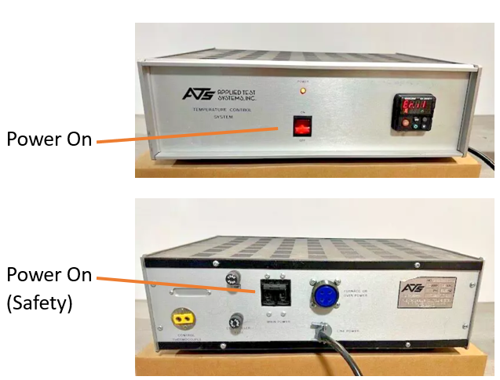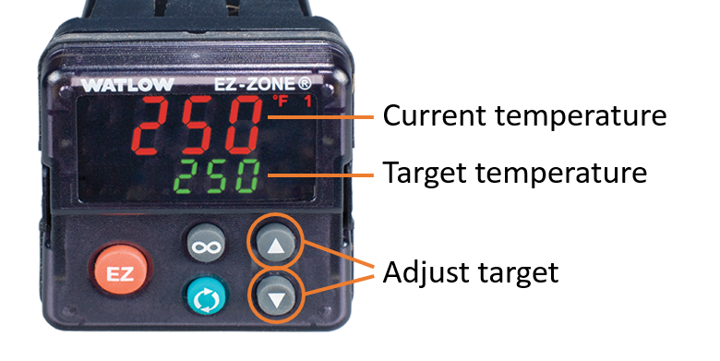
- Plug in the Arduino (using the enclosure USB cable or power adapter wall plug), power supply, and winder to power them up (flipping switches as necessary). Keep the feeder and winder off at this time.
- Plug in the laser micrometer and turn on the chiller power supply as well. Ensure the chiller has enough water in its reservoir. Do not insert the chiller into the furnace yet though.
- Set the desired feed speed with the top dial (rotary potentiometer).
- Set the desired control mode for the winder – either on-board, using the lower rotary potentiometer, or off-board, using the FilaWinder rotary potentiostat built into the winder unit.
- Set the direction control to auto (mid-point) unless taking manual control of the system – the direction can be overridden manually at any point by switching the direction control rocker into either the left (down) or right (up) positions.
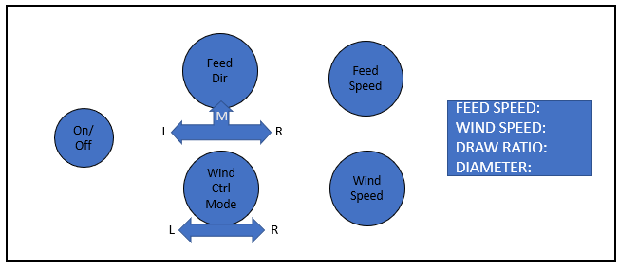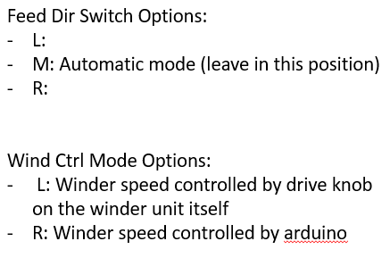
- Once the enable switch is thrown, the program should kick in and begin lowering the carriage slowly down – to disable the movement, the enable switch can be thrown into the off position at any point.
- If needed, while in auto-direction mode, the bottom limit switch can be manually triggered (with a quick press and release) to force the control software into a loop set at max speed in reverse until the top limit switch gets triggered.
- Flip the enable switch to prevent any movement during loading.

- Load the pre-formed cylinder into the clamps and make sure it is aligned properly with the hole in the top and bottom of the furnace from multiple viewing angles.
- Below the furnace after a certain amount of time, collect the drop/thread that descends and place it into the winder collection wheels.
- Assist further with the necessary steps to get the winder collecting the filament into a steady-state.
- Flip the enable switch into the on position to begin the drawing process.
- Once a steady-state has been reached, the program should run until either the entire cylinder has been drawn and the carriage triggers the positive (bottom) limit switch, at which point it should return to the top position and the software loop resumes.
- Once completed, the enable switch should be thrown into the off position to stop the loop.
- Power down the motor power supply to ensure that it cannot be accidentally activated.
- Open the clamp and release the remaining feed cylinder for storage or disposal.
- Turn down the setpoint of the temperature controller of the furnace so that the temperature is displayed the whole time – powering the unit off is another option, but once off, there is NO INDICATION of temperature, making warning signage important for protecting any lab users come into the lab close to the shut off time.
- Record the material, temperature set-point, feed speed, and wind speed for your records.
- Unplug the Arduino.
- Turn off the winder.
- Collect the drawn fiber from the winder spool.
- The system should be ready for another run at this point.

Troubleshooting and Maintenance
For all troubleshooting and maintenance, please contact Luka Morita. :D
Luka Morita
lmorita@ualberta.ca
+1-587-501-3957

